

SCHOOL OF COMPUTING AND INFORMATICS

BACHELOR OF SCIENCE IN COMPUTER SCIENCE

UNIT CODE: BIT4138

UNIT NAME: ADVANCED CRYPTOGRAPHY

PROJECT TITLE: SECURE FILE ENCRYPTION SYSTEM

WEEK 1-5 SUMMARY

GITHUB LINK
https://github.com/xoashlyyy/ADVANCED_cryptography

NAME | REG. NO
ASHLEY JOY ONYANGO | BSCCS/2024/50264

LECTURER: Mr. MICHAEL NYORO
SUBMISSION DATE: 08/06/2026

Contents
Week 1: Cryptography Environment Setup 3
Week 2: Classical Cryptography and Cipher Design 5
Week 3: Stream Ciphers and Randomness Testing 9
Week 4: Block Cipher Design and AES 10
Week 5: Public Key Cryptography (RSA) 12
Creative Project: Interactive Crypto Vault Dashboard 13

Table of Figures
Figure 1: Installation of Python and VS Code 3
Figure 2: : Installation of Cryptography Libraries 3
Figure 3: OpenSSL Installation Test 4
Figure 4: Local Encryption Python Script 4
Figure 5: Local Encryption Script Execution 4
Figure 6: GitHub Repository Initialization 5
Figure 7: Caesar Cipher & Vigenère Cipher Python Script 6
Figure 8: Encryption and Decryption Output 7
Figure 9: User Input Validation Python Script 7
Figure 10: User Input Validation Output 8
Figure 11: LFSR Generator Implementation Python Code 9
Figure 12: Pseudorandom Sequence Output 9
Figure 13: Statistical Randomness Testing 10
Figure 14: Encryption Performance Python Code 10
Figure 15: Encryption Performance Results 10
Figure 16: AES Encryption Python Script 10
Figure 17: Key Generation Process 11
Figure 18: Encryption process 11
Figure 19: Decryption Process 11
Figure 20: File Encryption & Decryption Results 11
Figure 21: RSA Key Pair Generation 12
Figure 22: Public Key Encryption Process 12
Figure 23: Private Key Decryption Process 12
Figure 24: Secure Message Transmission 12
Figure 25: Message Decryption 12
Figure 26: Requirements Installation(CP) 13
Figure 27: Interface Architecture 14
Figure 28: Backend Integration 15
Figure 29: Interactive Encryptor 15

Week 1: Cryptography Environment Setup
Installation and Configuration of Cryptography Development Environment
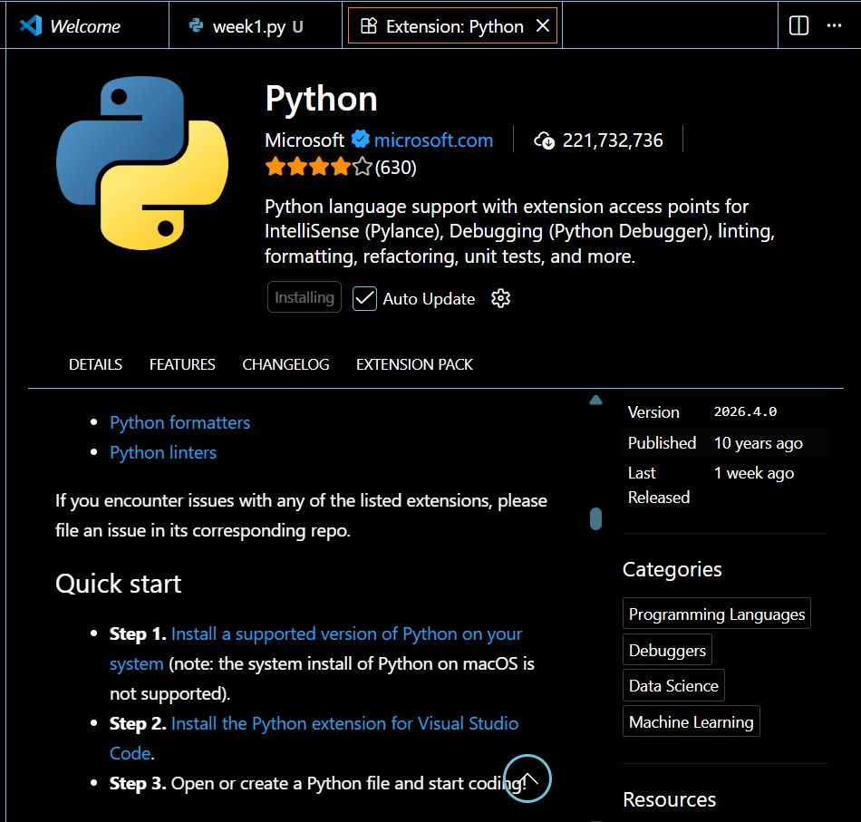
Figure 1: Installation of Python and VS Code
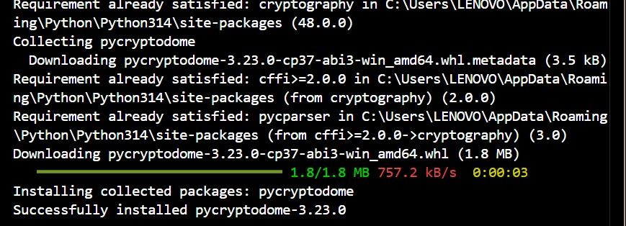
Figure 2: : Installation of Cryptography Libraries
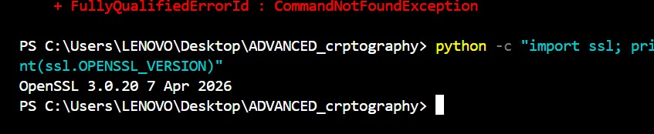
Figure 3: OpenSSL Installation Test
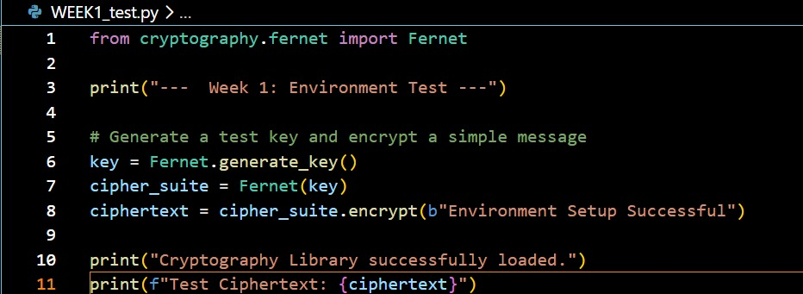
Figure 4: Local Encryption Python Script
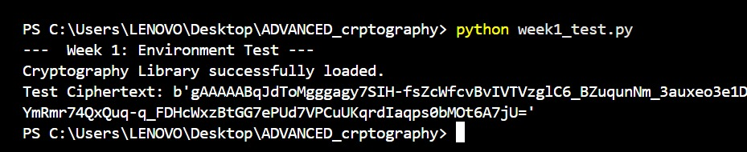
Figure 5: Local Encryption Script Execution
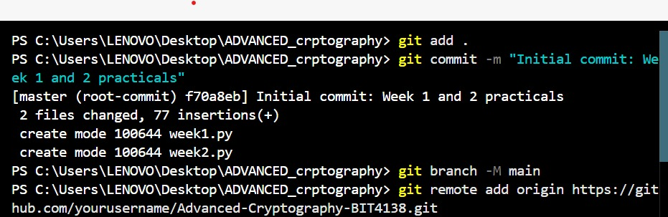
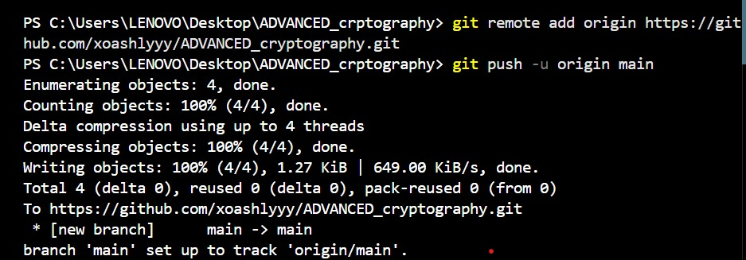
Figure 6: GitHub Repository Initialization

I successfully configured the Python development environment and VS Code for cryptographic operations. OpenSSL was installed for generating secure keys and certificates, and Git was initialized for version control. These tools establish the technical foundation for implementing secure encryption algorithms in subsequent tasks.

Week 2: Classical Cryptography and Cipher Design
Implementation of Classical Encryption Algorithms
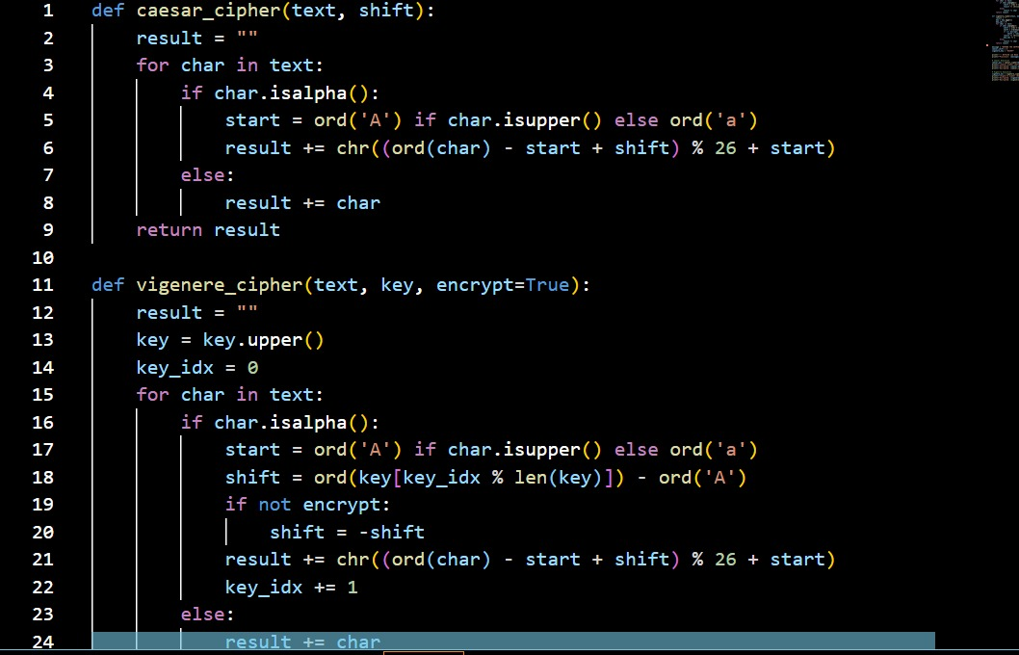
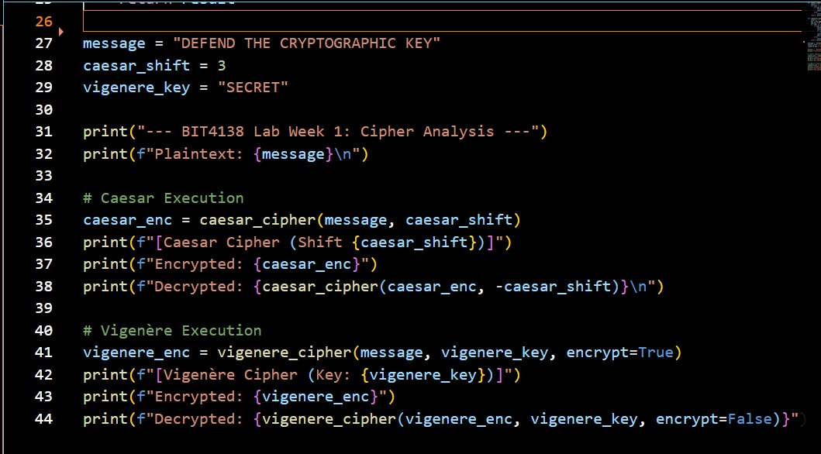
Figure 7: Caesar Cipher & Vigenère Cipher Python Script
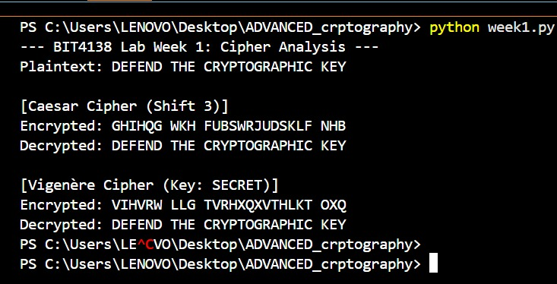
Figure 8: Encryption and Decryption Output

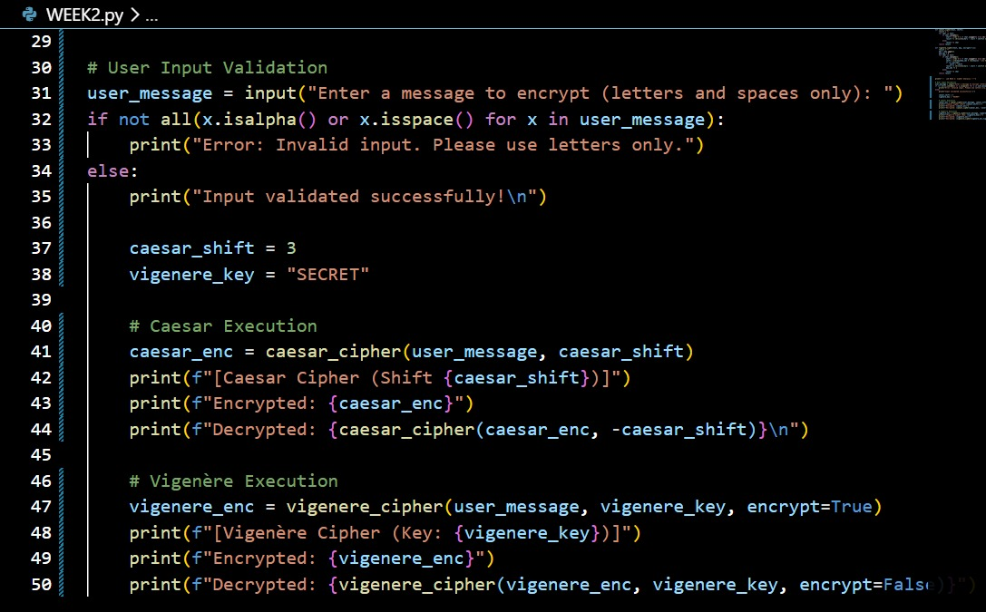
Figure 9: User Input Validation Python Script
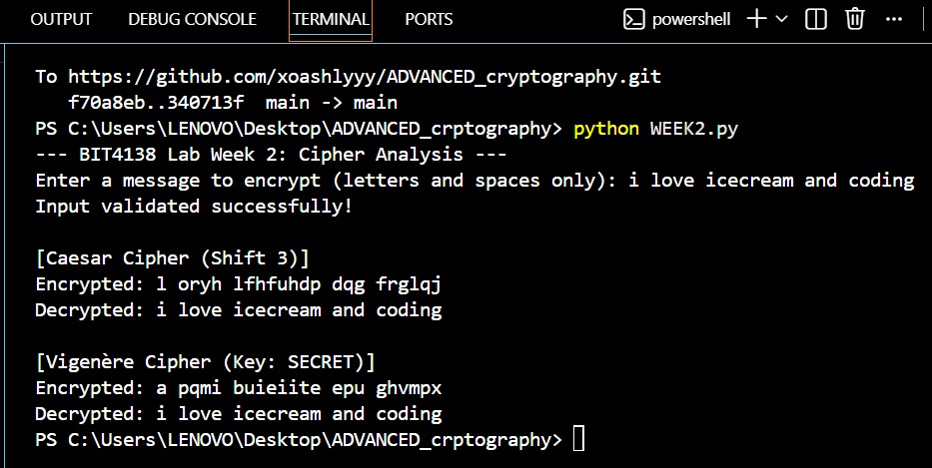
Figure 10: User Input Validation Output
I built interactive Caesar and Vigenere ciphers, testing their encryption workflows. I learned that while Caesar is easily broken due to fixed shifting, Vigenere’s multi-character keys drastically improve security by obscuring character frequencies. The outputs confirm polyalphabetic substitution effectively mitigates the core vulnerabilities of classical monoalphabetic algorithms.

Week 3: Stream Ciphers and Randomness Testing
Implementation of Stream Cipher Systems and Random Sequence Analysis
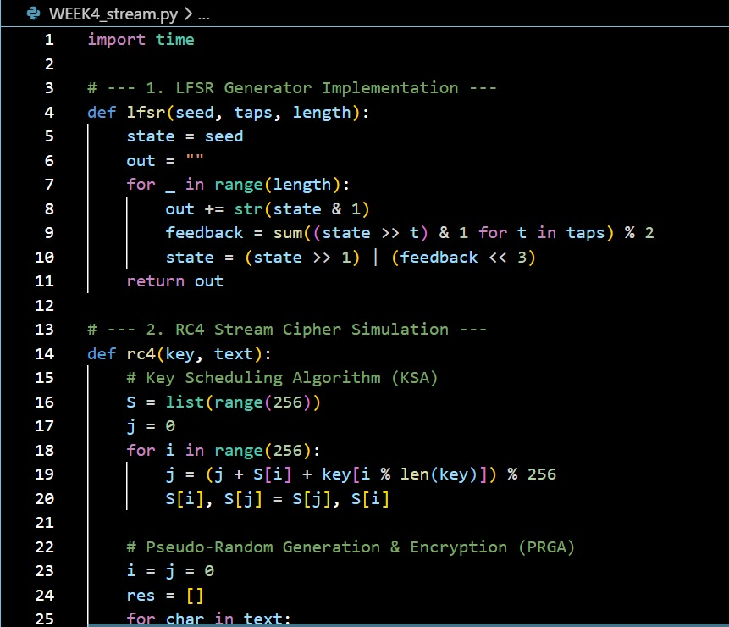
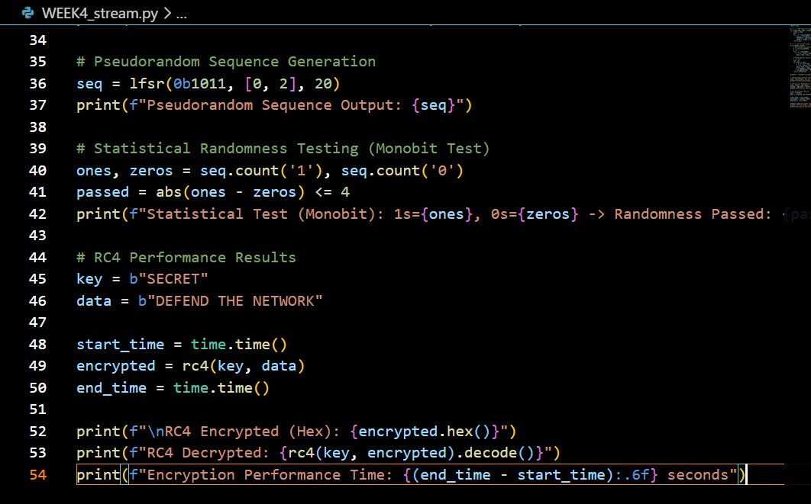
Figure 11: LFSR Generator Implementation Python Code

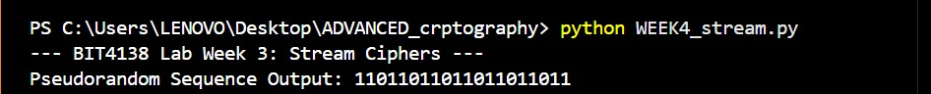
Figure 12: Pseudorandom Sequence Output
Figure 13: Statistical Randomness Testing
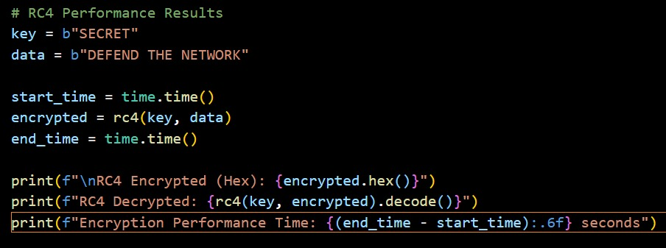
Figure 14: Encryption Performance Python Code
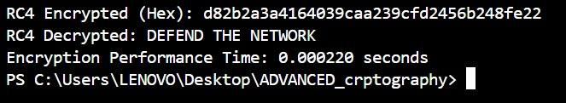
Figure 15: Encryption Performance Results

The RC4 implementation demonstrated real-time stream encryption where data is encrypted bit-by-bit using a keystream. Statistical randomness tests, including frequency analysis, were utilized to evaluate the unpredictability and quality of the generated pseudorandom sequences, ensuring secure cipher operations.

Week 4: Block Cipher Design and AES
Advanced Encryption Standard (AES) and Block Cipher Operations
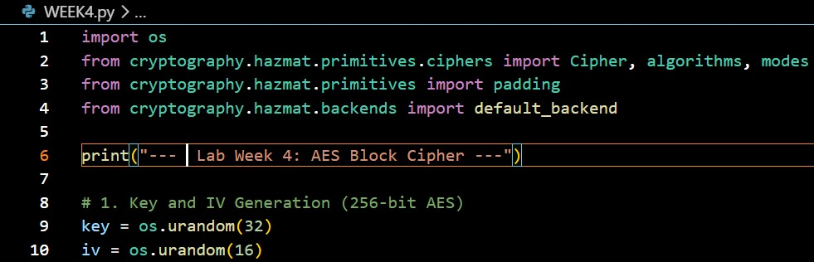
Figure 16: AES Encryption Python Script
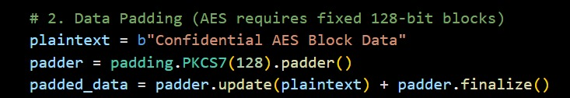
Figure 17: Key Generation Process
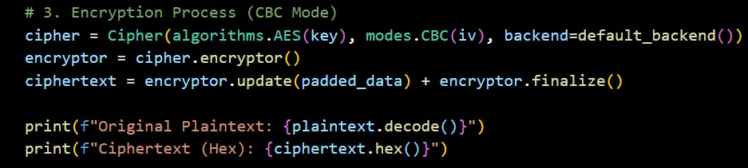
Figure 18: Encryption process
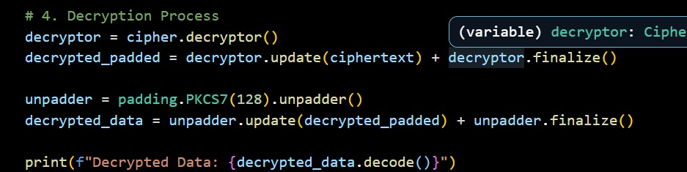
Figure 19: Decryption Process
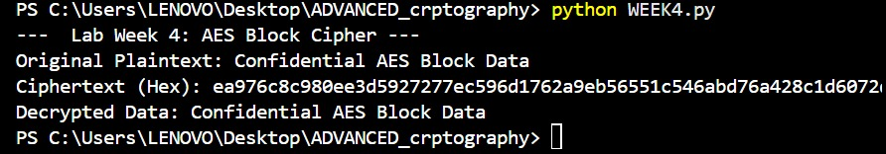
Figure 20: File Encryption & Decryption Results

AES encryption was utilized to securely encrypt text files, emphasizing the importance of symmetric key generation and handling. The implementation highlighted how block ciphers process data in fixed sizes through multiple rounds, successfully demonstrating secure encryption and decryption workflows.

Week 5: Public Key Cryptography (RSA)
Implementation of RSA Encryption and Key Management
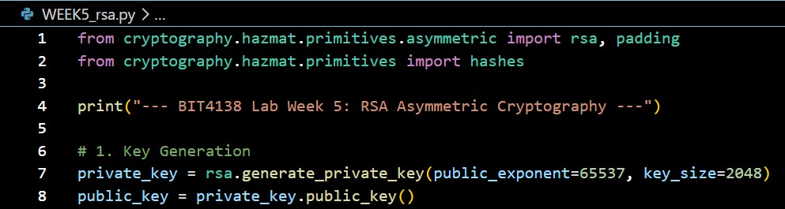
Figure 21: RSA Key Pair Generation
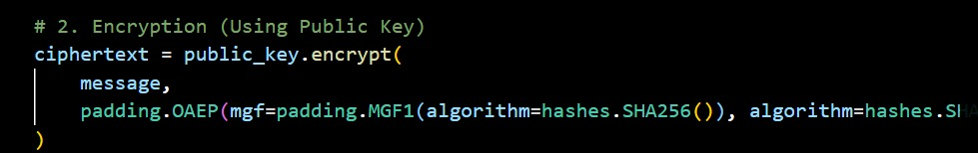
Figure 22: Public Key Encryption Process
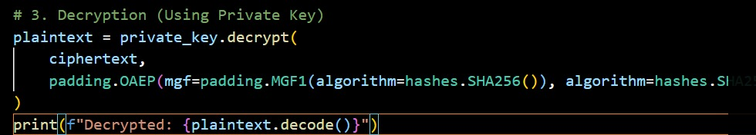
Figure 23: Private Key Decryption Process
Figure 24: Secure Message Transmission
Figure 25: Message Decryption
RSA asymmetric encryption demonstrated secure communication by separating keys into public and private pairs. The implementation highlighted the security advantages of using a public key for message encryption, while successful decryption was restricted strictly to the corresponding private key.

Creative Project: Interactive Crypto Vault Dashboard
1. Environment Setup
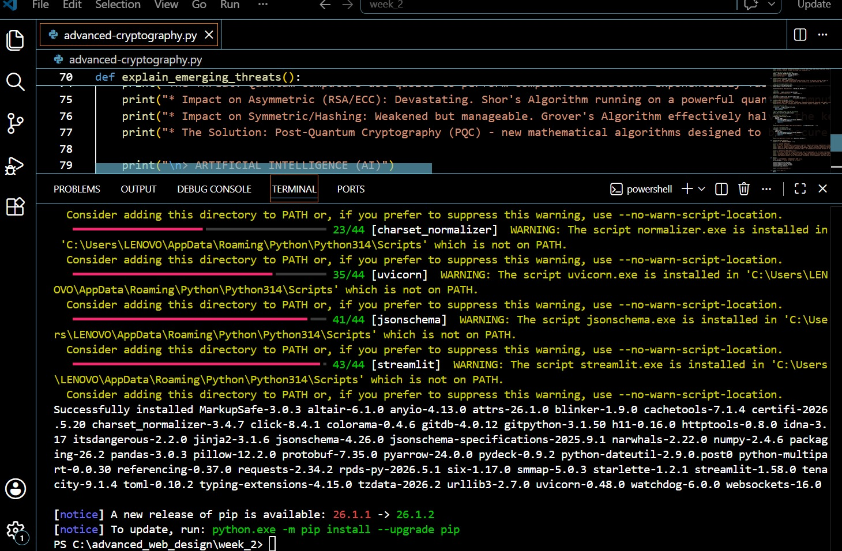
Figure 26: Requirements Installation(CP)

​3. Interface Architecture
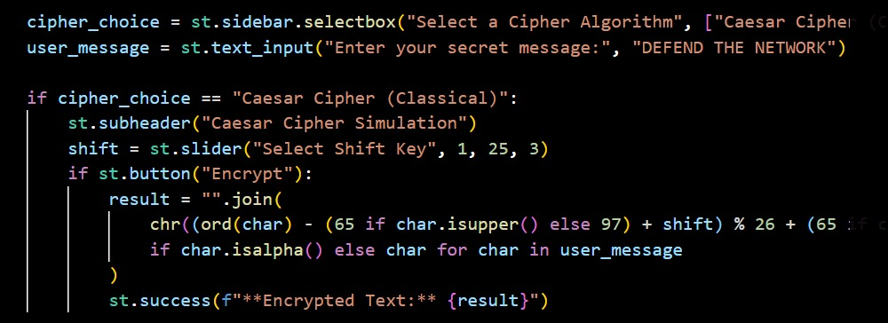
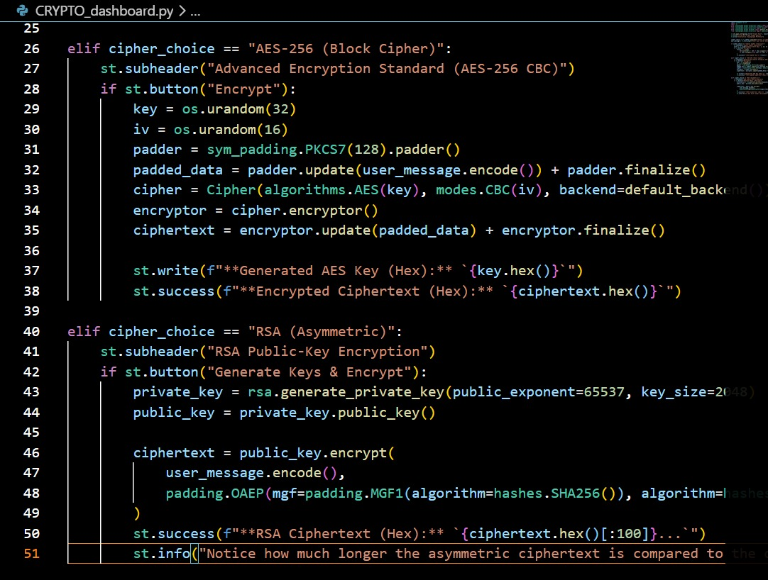
Figure 27: Interface Architecture

​4. Backend Integration
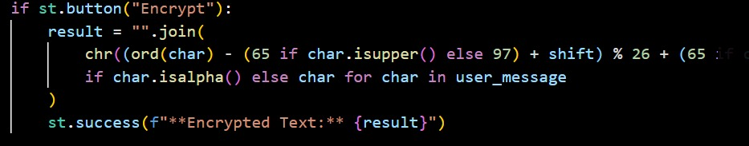
Figure 28: Backend Integration

​5. Input & Event Handling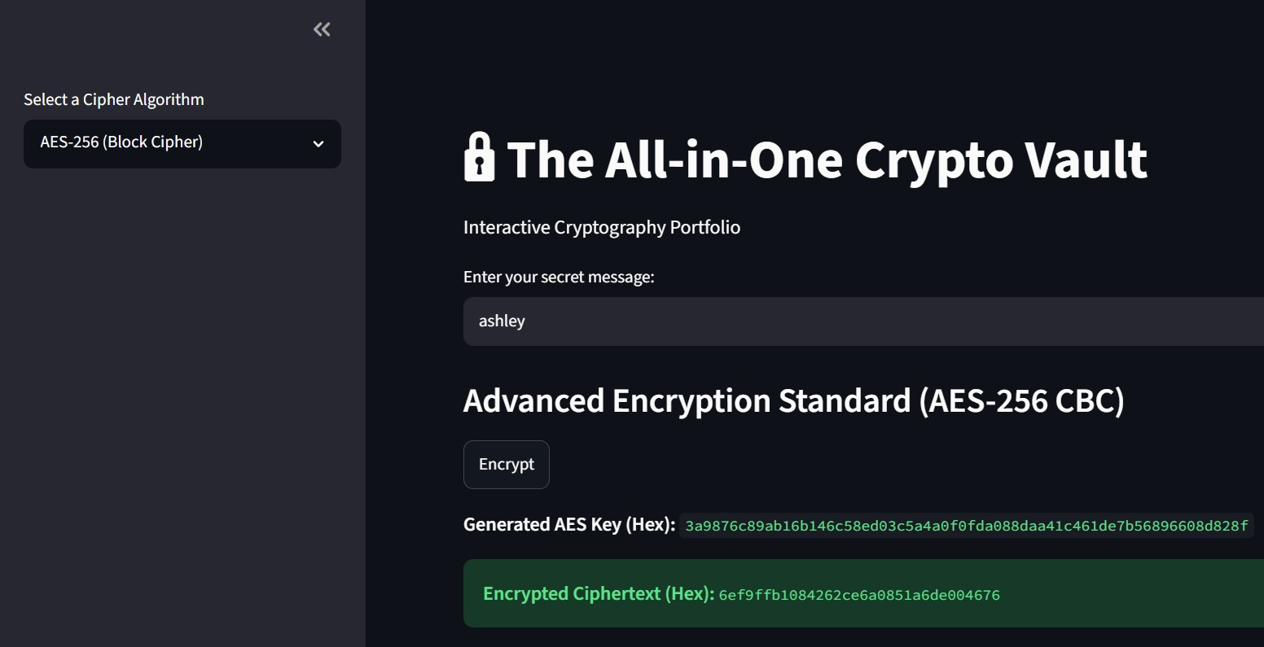
Figure 29: Interactive Encryptor
Building the Interactive Crypto Vault Dashboard using Streamlit successfully bridged complex cryptographic mathematics with an accessible frontend experience. Consolidating standalone cipher scripts into a unified, responsive application allowed for real-time encryption testing. This practical project reinforced how graphical interfaces significantly enhance the usability of advanced security algorithms.
​

